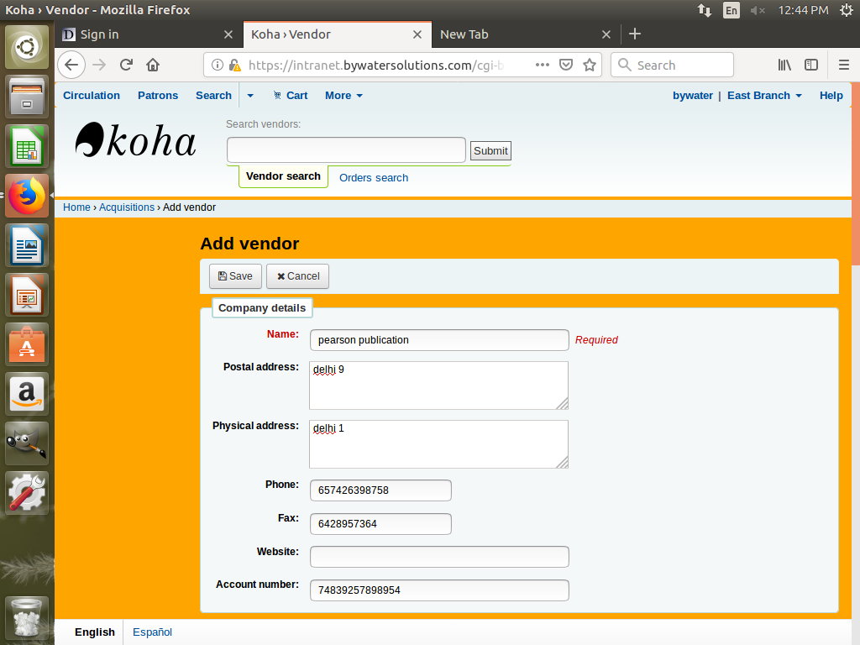

Step one – we fill basic publication detail

Step 2- vendor detail is filled

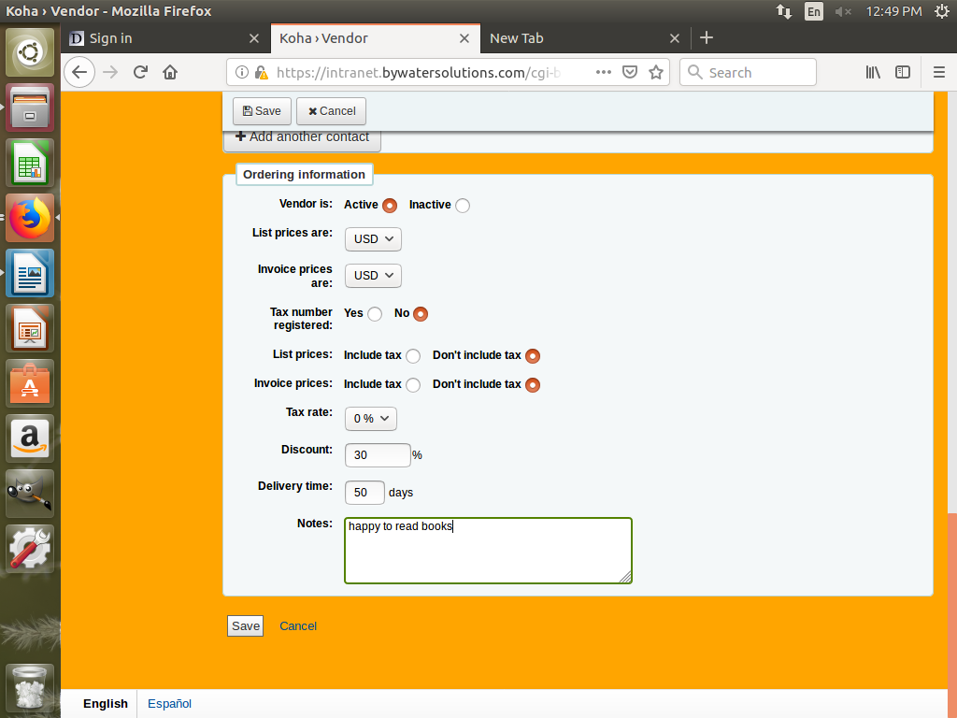

step 3- basket detail is filled for circulation

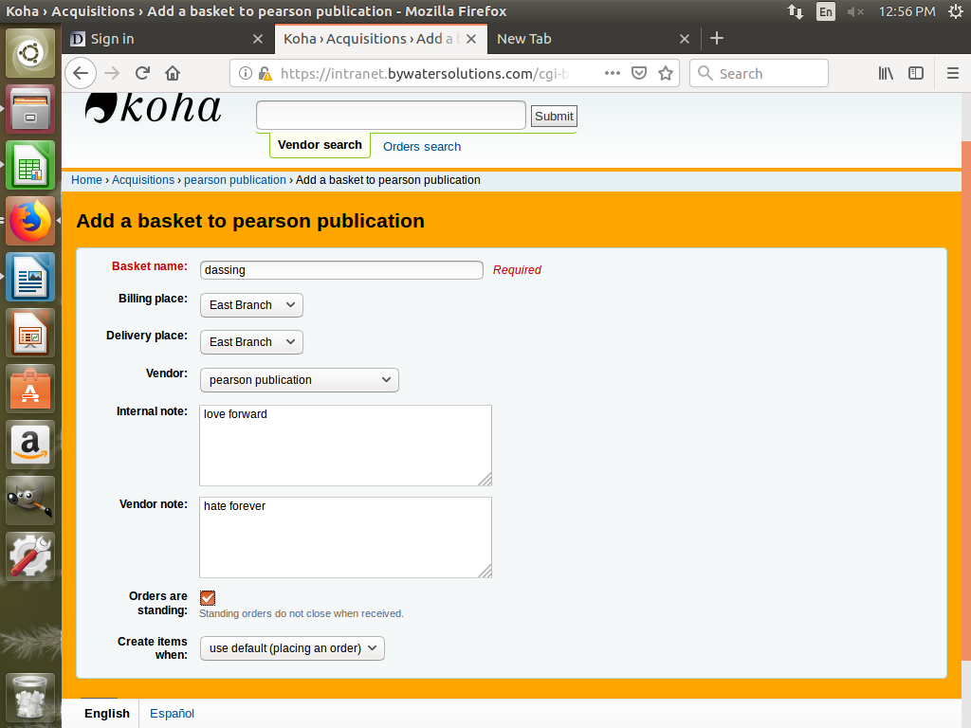

by-divyani and Ravender

